**JMeter CSV Data Set Config**

* Creating a Note pad.
* Save it as .csv file.

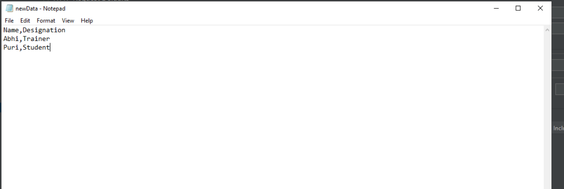

* Add 🡪 Threads 🡪 Thread Group

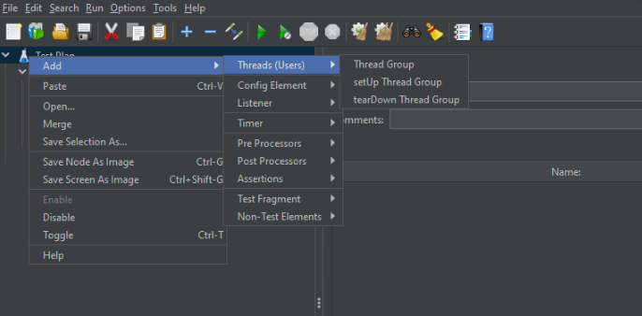

* Add 🡪 Config Element 🡪 CSV Data Set Config.

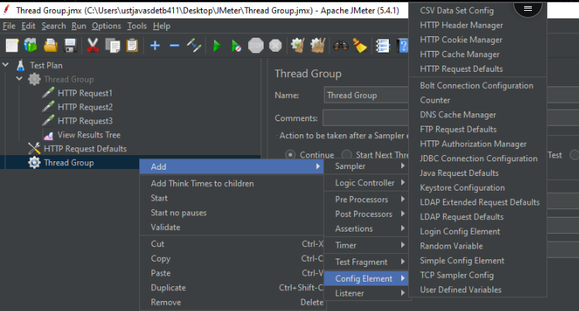

* Add 🡪 Sampler 🡪 Debug Sampler

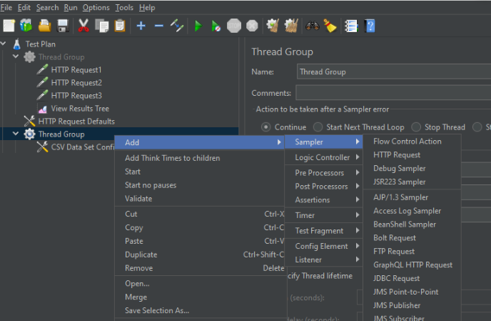

* Add 🡪 Listener 🡪 View Result Tree

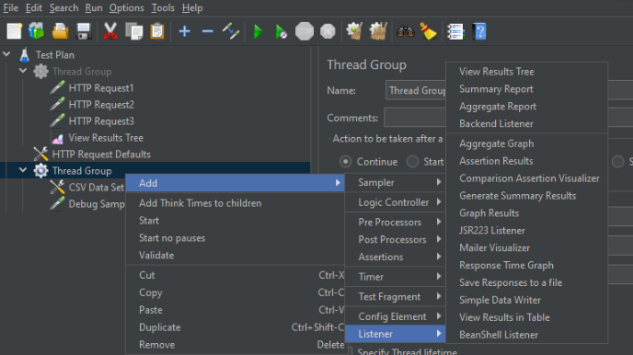

* Browse .csv file in CSV Data Set Config

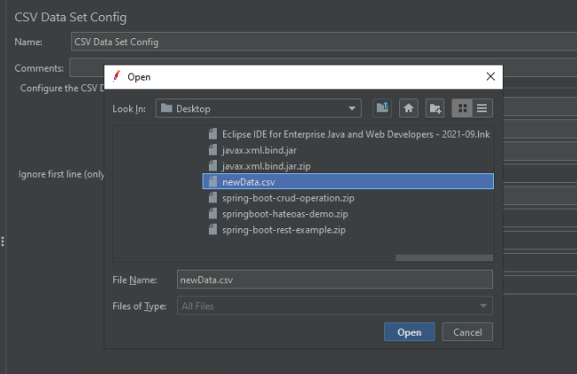

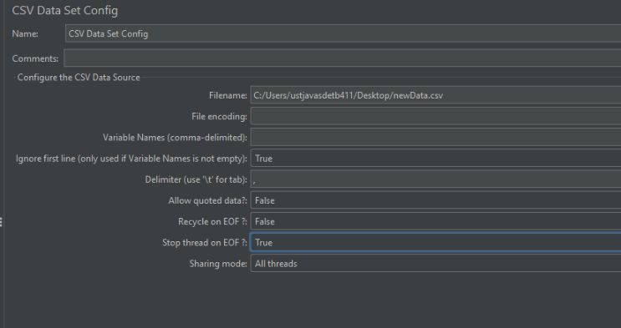

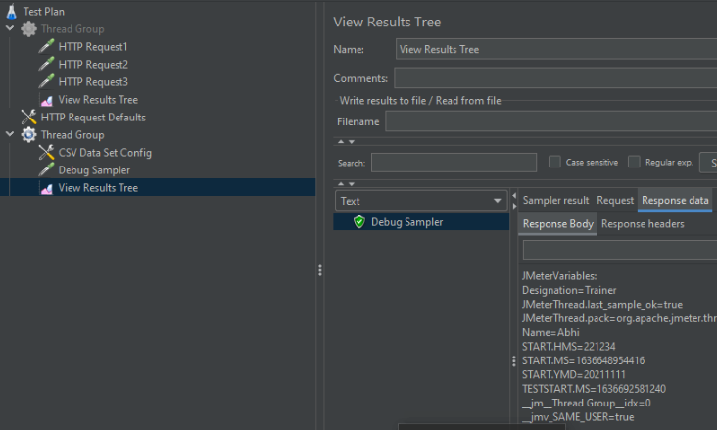

* Change the Number of Thread to 3.

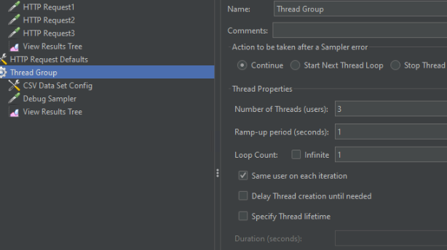

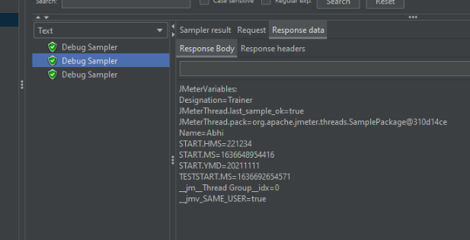

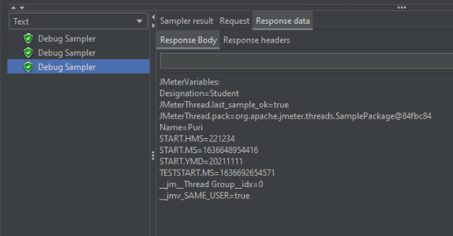

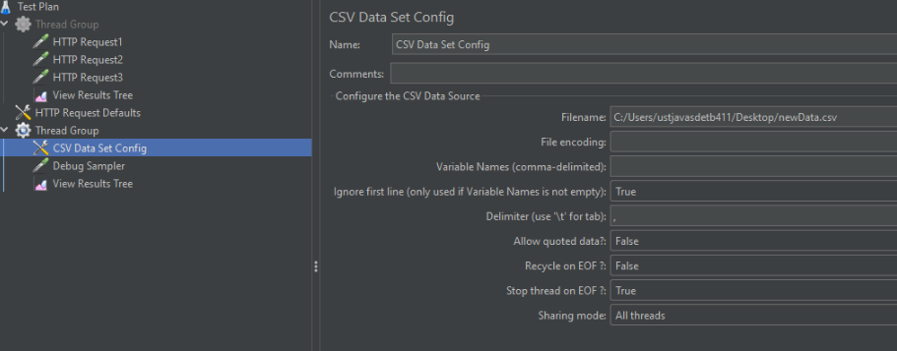

* If there are 2 sets of data then at least 2 users are required.
* Here we have given User No: as 3 but it will execute only 2.

